GUDE Assessment
Section 1 35%
1) Explain concept model for the application, explicitly describing how the domain and the locational/geocaching model is used
2) Identify usability concepts
3) Operationalise usability concepts - how to measure these concepts
4) Define task allocation across the systems
Write in 3rd person / we actively
Getting Usability into Development Environments
Section 1
The Purpose of the System
The domain for this application is language learning. The aim is that users will be able to learn languages contextually via geocaching and memory techniques with flashcards. To make the process of language learning more efficient, the app will allow users to unlock vocabulary in their target language based on locations they visit. This idea allows the user to more efficiently learn the words that they will regularly come across in daily life.
The user will also gain experience points for each place they visit, encouraging them to learn more if they want to and therefore visit more places and gain more caches. As a user studies, they will also gain experience points so that users who study more gain more experience and higher levels. Certain rarer locations that will contain harder words will be level locked, so that only users who have gained enough experience points can unlock and learn them.
The overall purpose for the user is to be able to learn languages in an efficient yet fun way, as if the entire learning process was a game.
Within the app they should be able to:
- Create an account and sign in.
- Use a map to find geocached vocabulary flash card sets.
- Learn and review sets of flash cards.
- Skip separate flash cards in case of issues with difficulty.
- View their progress, level and experience points.
The target users could be anyone who wants to learn a language and as
such could be of any age. For usability testing purposes people between the ages of 18-50 will be selected for prototype testing.

How Caching is Used in This System
The app will display a list of categories of locations, such as “Train station” or “University”. The user can then click on one and a list of locations will appear along with coordinates and distance from the user. If the user clicks on one of these options, then more information such as a map and information about the words they can learn will appear. The user then heads to the location using the information supplied by the app. When they enter the radius of the geocache, a notification will automatically appear on their phone and will tell them that they have gained a new set of cards and some experience points. This will then get updated to the user’s profile and synced to the cloud. These updates will then be sync across devices when the user logins in (on a device).

Usability Concepts
DISCUSS WHY YOU HAVE/HAVEN’T USED CERTAIN RULES ETC
Usability needs to be a high priority as users are expected to be of varying ages and will be using a variety of different devices. The app should be easily usable to a point that the user does not make too many mistakes to get to a certain point or to do a certain task. Jakob Nielsen has invented several usability evaluation heuristics to help improve the usability of systems fast and cheaply, in hope to solve issues like these for software designers. He has 10 heuristics on usability for User Interface Design which will be used in this system, along with suggestions from other experts, to identify and measure usability.

This system has two main concepts. Find new flashcard decks via geo-caching, and studying found flashcard decks. Having two main concepts means that the system should be designed in a way that keeps the user informed as to what they are doing all the time, so that they do not get confused. Nielsen (1995, para 2) states that users should always be kept informed about what is going on via appropriate feedback and within reasonable time. For this system, this includes such things as confirmation messages, possible loading screens and possible help documentation. If documentation is included then Nielsen (1995, para 11) also suggests that it should be easy to find, focused on what the user’s task, a simple list of instructions and not too large. This system will be designed in a way that should mean that help and documentation is made redundant, however, as an added extra it can’t hurt the user if it is added in.

When considering content in the app, the terms and language that is used must be simple to the user rather than complex system terminology as Nielsen (1995, para 3) states. For example, mentioning “caches” in a geocaching app is not always that helpful, as most users may not realise what geocaching is or even what a cache is. For simplicity, it is better to use phrases that any user, new to the subject area or not, will be able to understand. In this systems case, there is a good chance that if a user is learning a language, they may wish to change their display language. This will make the app much harder for them to use, but lots of people do this to help learn languages. Due to this, the system must use simple language with a combination of buttons and images. This also has an influence as to how they will use the app as well. As such, this will affect the order in which information will appear. Content will need to be displayed in a logical order to prevent confusion.

As Nielsen (1995, para 5) says in “Consistency and standards”, you should not confuse users by using different terminology, situations or actions when they actually mean the same thing. This is also suggested by the Android User Experience Team (n.d., para 13) where they say that if something looks the same then it should always work the same. Consistency across the system is important to prevent confusion for users.

The app should have an easy learning curve and should be very simple to cater for all ages. Shneiderman (n.d., para 10,11) states in his Heuristics that reducing short-term memory load is a must as you want to avoid interfaces where users must remember information between different displays. Now, this will be in that GUIs to certain extent as the design of the flashcard quiz requires users to have to remember information. However, this does not mean that use of the rest of the system should be taxing on the user. By reducing short-term memory load in this way throughout the rest of the system, users should find learning new words or grammar rules when studying a lot easier. This is because they will have less things to remember, meaning they have more potential to learn more.

Operationalise usability concepts
In Usability Metrics (2001, para 5) Nielsen lists the most basic measures of usability which he lists as follows:
- Success rate (can users perform the task?)
- Time taken to complete a task
- Error rate
- User satisfaction
He also mentions other possible metrics such as the amount of times users need to backtrack to find the correct window/page. He then goes on to discuss comparing two designs and how to quickly tell if a new design has improved in usability. He recommends taking tasks that the user must do then to record how long it takes the user to complete the task.

To do this you would gather the data for each design first then, for each one, add up the time taken so you get what he calls a “how long it takes users to do stuff” for each design. From here you can simply calculate a percentage improvement based on the time difference. He also means though that this can be misleading as if certain tasks are not performed as often but improve in efficiency then these tasks could skew the results. When some tasks are performed more than others, it is better to work out percentage of improvement separately first and then get a geometric mean of the tasks percentages. By doing this you then get a fair “usability score” which can tell you just how higher or lower usability is for a new design.

At first, low fidelity prototypes will be created. Then, following this simple but effective method for measuring usability, the prototypes will be tested with sample users and results will be recorded. During the testing the users will be given set tasks and the time taken to complete these tasks will be measured. After this process is complete, analysis will be done on how to improve the results of the tests that have been conducted.

This should be done with some form of control test results to give some idea as to whether a task has taken a long time or not, equally, using enough testers should bring to light any mistakes that users are making. After the test results have been analysed, a high-fidelity design can be made with improvements. Once a high fidelity has been made, tests for tasks will be conducted and results recorded. Changes will then be made and updates to the prototype to increase usability will be considered, implemented and the system will then be tested again.

Task Allocation
The following table shows the tasks that will be performed throughout the system. Each task will be caused by an action caused by user input or due to an action in the system itself.

Task | Mobile | Desktop | Server | User
Look up possible caches | Yes | Yes | No | Yes
Check progress | Yes | Yes | No | Yes
Sync data across devices | Yes | Yes | No | Yes
Store data | Yes | Yes | Yes | No
Check map | Yes | Yes | No | Yes
Review flashcards | Yes | Yes | No | Yes
Obtain flashcards from cache | Yes | No | No | Yes
Obtain experience points from cache | Yes | No | No | Yes
Get data from google maps (e.g. whether the current location is a shop, bank, park etc.) | No | No | Yes | No
Sign in/Create account | Yes | Yes | No | Yes
Create/edit account info | Yes | Yes | No | Yes
Change display language | Yes | Yes | No | Yes
Change learning language | Yes | Yes | No | Yes
Authorise account/sign in | No | No | Yes | No
View map | Yes | Yes | No | Yes
Skip flashcard | Yes | Yes | No | Yes

Potential Issues
The app could have a huge variety of accessibility issues, especially for the mobile version. There are many different types of disabilities out there and many are affected by "small screens", for example, partial blindness. In this case the user would prefer a large screen to see the app on and may own a tablet for this purpose. However, if this app is not optimised for accessibility and the buttons are still small or the text is just as small as a normal mobile version, then the user will have a hard time using it. The user will be using the mobile app outside which could have some environmental issue which should be included. For example, glare could affect the ability to see the screen so this may affect the colour scheme.

Section 2 45%
1) Initial Interface Specification
2) Low fidelity prototypes for both Mobile and Desktop applications
3) Quick and dirty initial empirical evaluation
4) Interface Specification modification
5) High fidelity prototypes for both Mobile and Desktop applications (must use Visual Basic for the Desktop prototype)
6) Quick and dirty empirical re-evaluation
7) Interface Specification modification
Section 2
Initial Interface Specification
Make sure that the distinction between applications is clear
The below site map gives a brief overview as to how each page is connected via each other. Each page on the 3rd layer can be accessed by each other on the desktop version whereas the mobile version just makes use of the built-in Android “back” button to go back to the previous page.
Site map
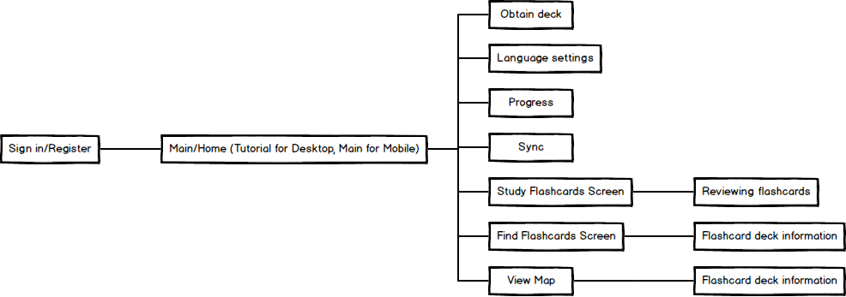
Figure 1 - Site map of both systems (check description above for details)
The Android User Experience Team (n.d., para 8) claim that “pictures are faster than words”, telling us to “consider using pictures to explain ideas” as “they get people’s attention and can be much more efficient than words.” This guideline is important as it is true that an app with the right balance of text and pictures will be more easily understandable than just an app with pure text. Take an icon button for example. Using a clearly understandable icon in place of a text button could make it quicker for the user to understand the function of the button. Based on this guideline the system will implement logos and small images that visually represent cache locations on a map, ticks for confirmation, graphs for progress and two arrows in a circle to mean “sync”. These images should be easy to understand for the user.
The left most image should be a “graph”, the next should be “sync” then the next is “change languages”.
Wireframe of Main Components
Find decks page
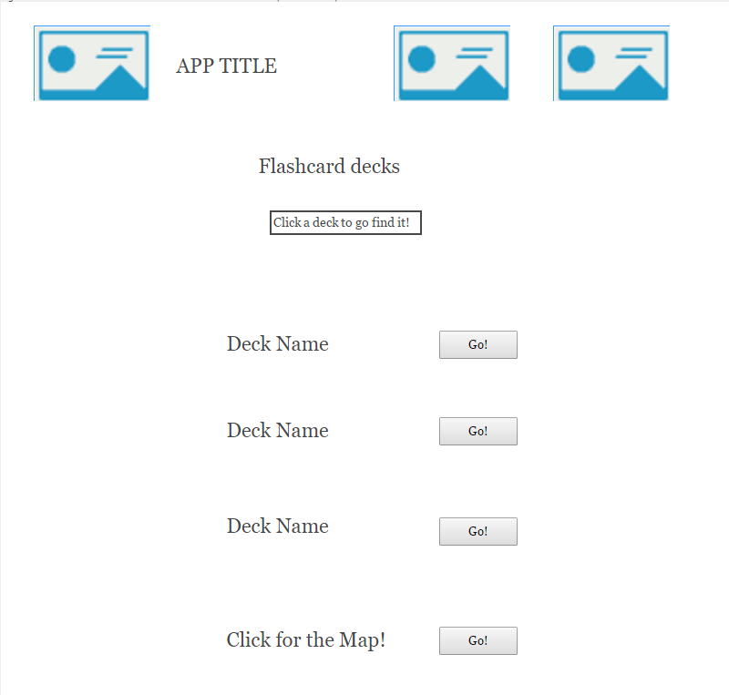
The Android User Experience Team (n.d., para 7) also observe that using “short phrases with simple words” is very important as “people are likely to skip sentences if they’re long.” This is an incredibly simple rule but is important to remember when writing any form of explanation on how to use certain features, button names, and even content itself. Small sentences, especially in a foreign language, are easier to read and understand than longer sentences. As the system is aimed at getting users to learn foreign languages with individual sentence flashcards (gained from caches) this guideline should also be taken into consideration for the apps cache content.
Lots of different types of apps will use buttons or linked text to take a person to the next page. For this system, both the text and the logo for each deck has been linked. This is because the user may not always realise that they need to click text, and may expect to click a button. Both the text and the buttons will take the user to the next page. This means that whatever the user is used to, their instinct will get them where they want to be.

Studying a Card (Front and Back)
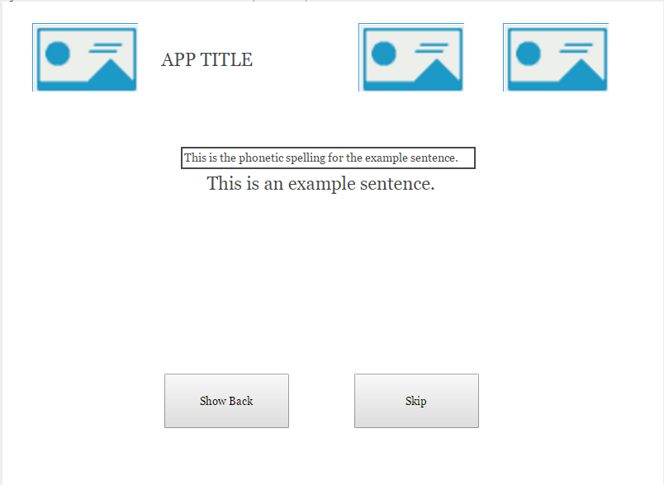
As mentioned before, use of simple sentences to make learning easier is essential. The top line is how the sentence is pronounced and the bottom line is the main sentence. Each language has methods for explaining its pronunciation so this will be included to aid users. This is more of a content choice than anything but it does influence usability. Including this makes it easier for beginners to learn how words are read and pronounced, reducing cognitive strain. The application should be able to teach a variety of people that are at different levels. By including this, we increase our accessibility and allow for a wider audience.

These top three buttons and the title should be kept the same through every page in the mobile application. Nielsen (1995, para 5) states in “Consistency and standards” that we should not confuse users by using different things that mean the same thing. Therefore, the images, logos and buttons used to represent features have been kept the same throughout the system. These buttons and images are also the same on the desktop version and they always appear at the top of the application. This will prevent confusion for users that will use both versions of the system.

Simple, large and clearly labelled buttons so that the user knows what each one does and what will happen when they click them. When the “Show Back” button is pressed, native audio for the sentence is also played. “Skip” will move the user on to the next sentence.

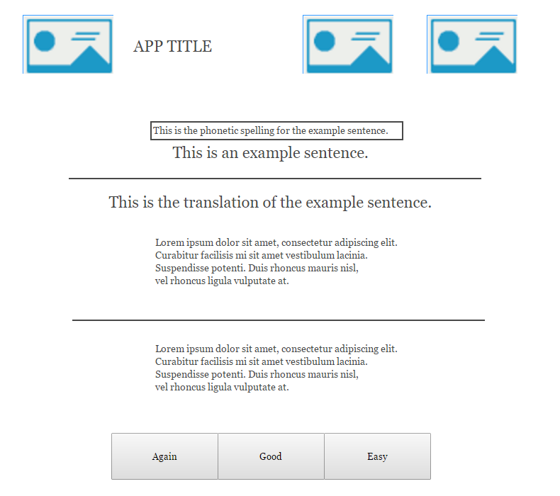
The back of the flashcard. Gives a translation of the original sentence, definitions of each word and grammar rule and any extra notes. The original front of the card is kept at the top so that the user can reference it.

Buttons here should be clearly labelled so the user knows how to grade themselves. A short line of text could also be included as a short explanation.

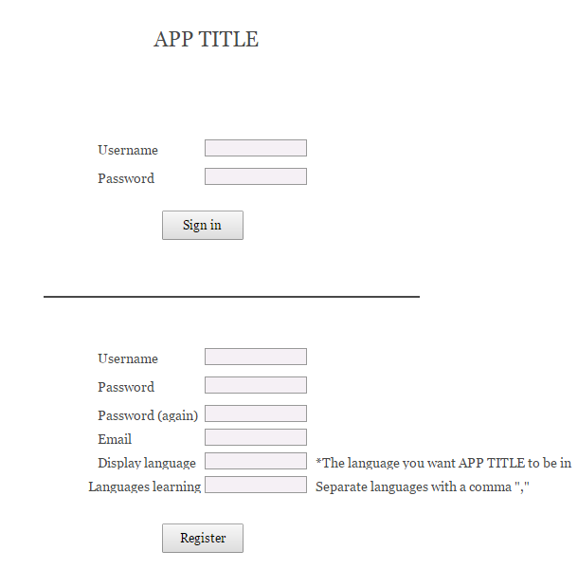
Helpful text hints that speak the users’ language, as recommended by Nielsen (1995, para 3). As “display language” might confuse some users, it would be best to add a hint explaining in a bit more detail what the system wants from the user. The last box has a hint incase users need to add multiple languages.
Nielsen (1995, para 6) stats that “careful design which prevents a problem from occurring” is “even better than good error messages”. This should be implemented here by giving instant feedback to the user as they type in to each field. If what they are typing is incorrect then the cross will turn to an “X” and a message will tell them how to fix the issue. This makes the registration process easier for the user which is important as this is the first stage of getting the user to use the system.
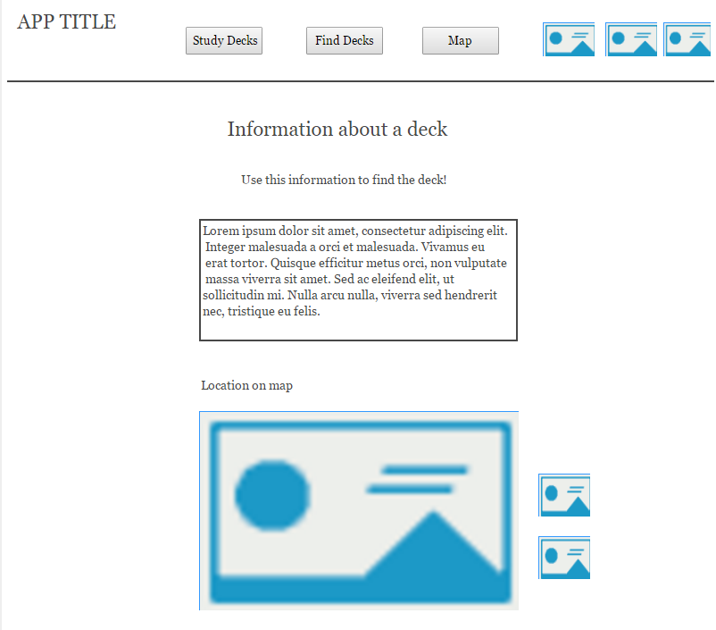
This is the map which will show the user where the deck is. It will contain standard images to identify the user’s location and the decks’ location to reduce cognitive load on users, as using text would make it hard to use. These should be easily understood by the user and will allow them to quickly understand what is going on.
For the desktop version, this “navigation bar” appears on every window besides the sign in window. This makes sure that the user can get back to the main functions of the system easily and so that they know where they are relative to the rest of the program.
This is where the information such as coordinates will go.

These will be small magnifying glass “zoom in” and “zoom out” images. The magnifying glasses tell the user that they can zoom in and out of the graph.

Low Fidelity Prototypes
What is, why use it, explain why used balsamiq, how are you going to get data from it, what process did you use to make the prototype
discuss how you printed the low fidelitys out and tested them with the users

Move this text to interface spec?
The mobile designs are meant for Android devices and we are assuming that the user has access to the back, escape and switch app buttons that comes with the Android OS so that they can navigate the application. Here is a quick description of both the mobile and desktop versions.
The first thing the user must do on either version is to register an account (if they don’t yet have one) or sign in. Once they have signed in they will be either taken to the home page (mobile) or to the find decks page (desktop).
For the home page on the mobile version, we have a simplistic layout that gives the user everything they need to know in one small place. They have three main options here. To study or find decks and to view a map. If the user clicks on the study option, then they will be taken to a page that has a list of decks that they have already found. An example of this page can be found in the appendix below (Figure _). Instead of a “home page” for the desktop version, we have a simple toolbar at the top where the user can access the three main features of the system.
From the study decks page, the user simply clicks on the deck and they can begin studying. From here they will see a sentence in their target language, attempt to read and understand it, then will click “Show back” to display the back of the card. Native audio plays during the pressing of the “Show back” button and the user will be able to look at the translation and meaning of the words in the sentence (as well as any other notes). They will then grade themselves as to how well they understood and read the sentence. Once they click a grade, a new sentence will appear. They will then continue this process until they click “back” on their Android device or until they have run out of cards to learn for today. The application will schedule cards per the Spaced Repetition technique for optimal learning efficiency.
If the user clicks the “Find decks” option, then they will be taken to a list of decks that are close to them. This will only include a certain number and if they wish to see more then they must click on the map at the bottom of the list. When they click on an option in this list they will be taken to an individual information page for that deck. An example of this can be seen in the appendix below (Figure _).
If the user clicks the “View Map” option, then they will be taken straight to the map so that they can view the locations of any flashcard decks.
If the user clicks the pie chart at the top of the application, then they will be taken to the progress page. If they click the circle created by two arrows, then a sync window will appear and sync the users’ progress with the server. If the user clicks the button at the top which shows different languages, then the user will be taken to their language settings. Examples of all these pages can be found in the appendix (Figures _ to _).

Mobile Low Fidelity
Sign in / register  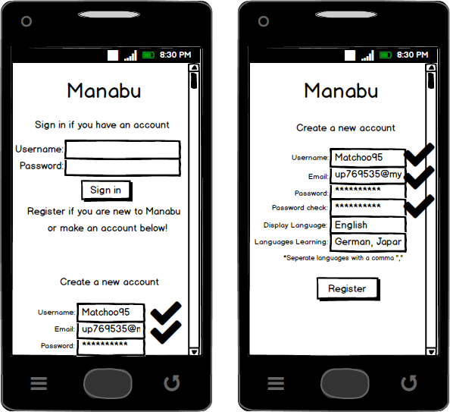 | Sign in / register | Home page for Android Users Only  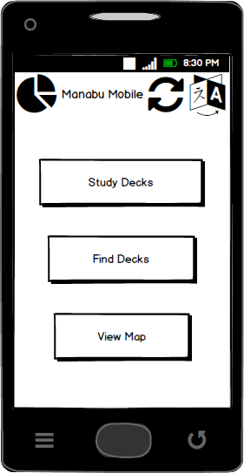
Map view  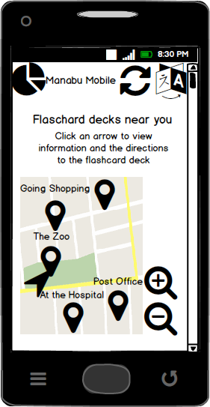 | Find decks page  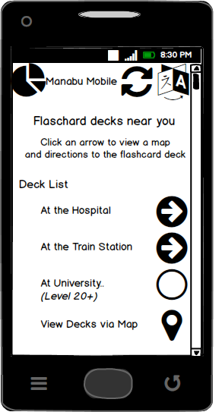 | Study decks page  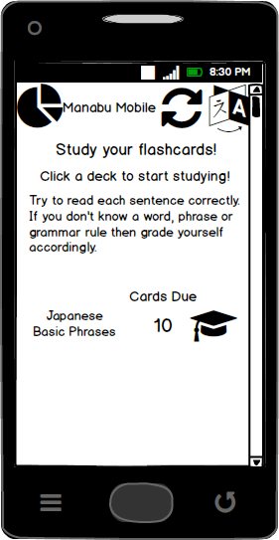
Studying a Card (Front)  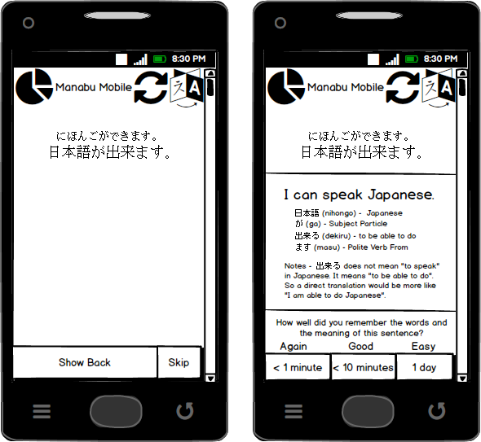 | Studying a Card (Back) | Information about a Deck  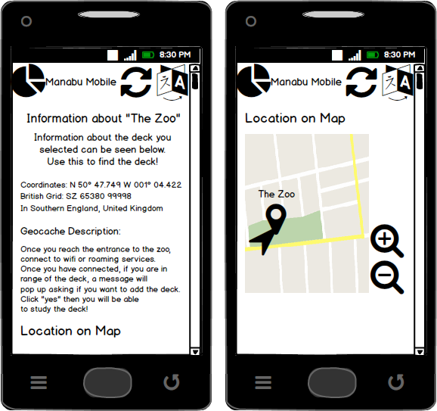
Information about a Deck | Progress Page  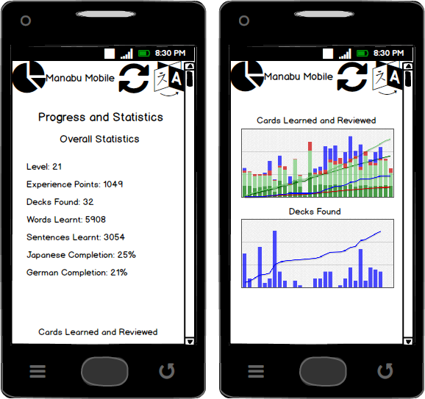 | Progress Page
Language Settings  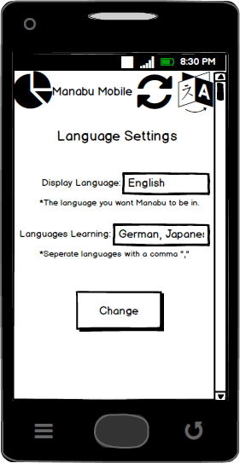 | Changed Details  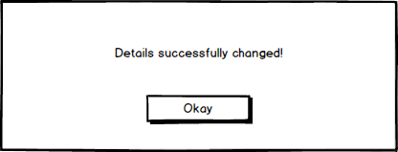 | Obtain new deck?  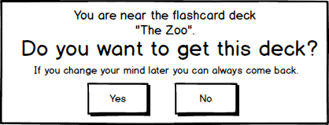
 | Sync  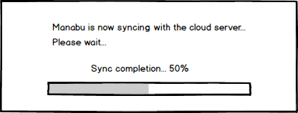 | Obtained a new deck!  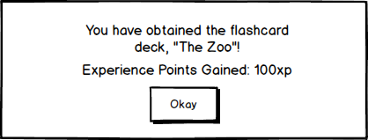

Desktop Low Fidelity
What is, why use it, explain why used balsamiq, how are you going to get data from it, what process did you use to make the prototype
Move this to interface spec?
The desktop version also includes some features for more experienced users such as shortcuts. For the above example “-“, “+” and “scroll wheel” can be used to control the map. When it comes to studying flashcards on the desktop version, users can use CTRL+Z to go back to a card and use the number keys to quickly answer cards.
The main differences between the desktop and mobile version is that the desktop version implements a larger navigation bar, whereas the mobile version uses a main menu to reach the same effect.
Sign in or Register
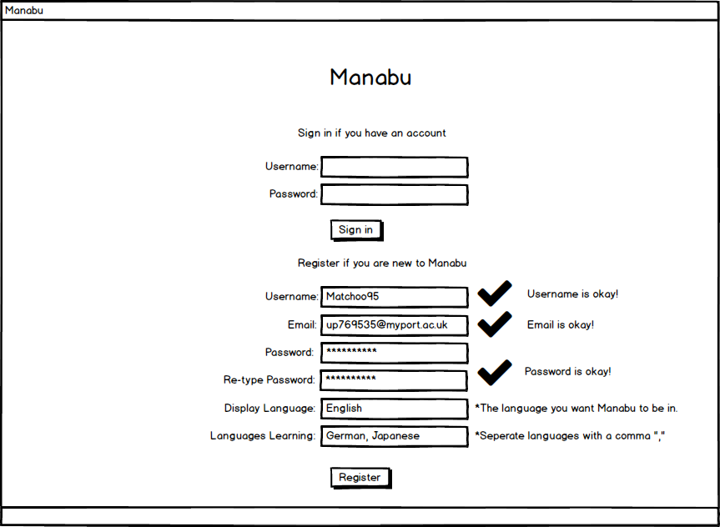

Information about a Card
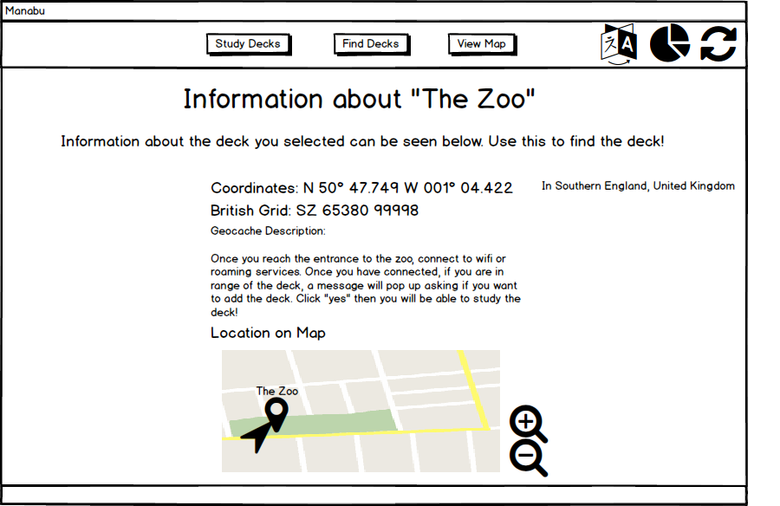
Interactive Map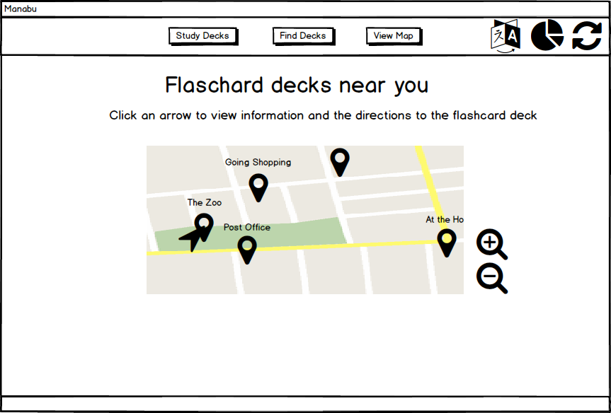
Empirical Evaluation
Talk about how you gathered the data, what process you went through during the interviews etc note changes need to the specification after each test session
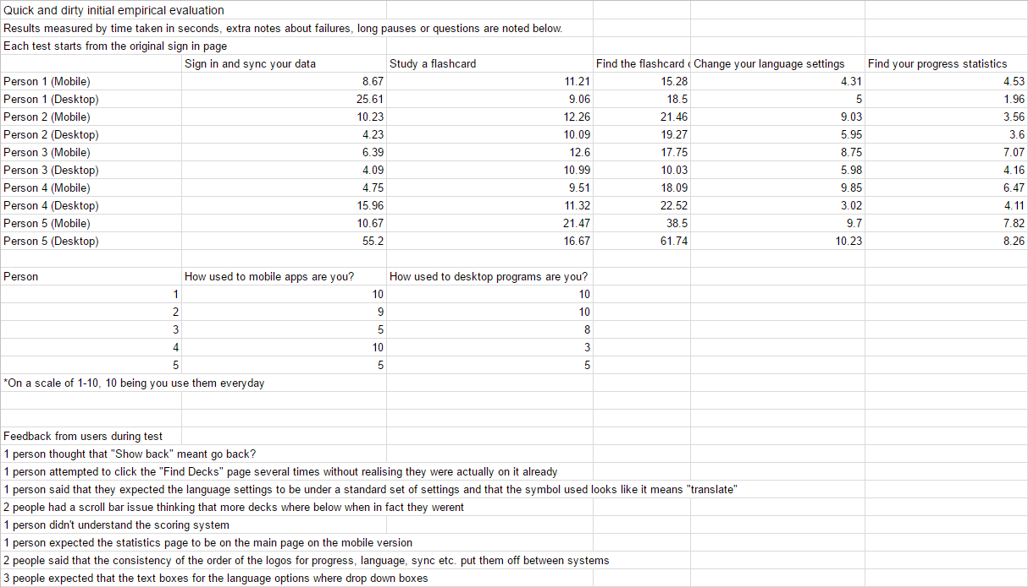
Mobile High Fidelity

Desktop High Fidelity

Section 3
Evaluation

Section 3 20%
1) Critical evaluation of, and reflection on your process, and the role of prototyping in empirical evaluation.

We expect you to upload
(as a single archive in ZIP format, named with your student ID, max size <100Mb)
1) Report
2) Software developed (demonstration in class)
3) Evidence of paper prototypes and evaluation

CHECK ALL YOUR REFERENCES
CHECK FOR DUPLICATE TEXT

Works Cited
"10 Heuristics for User Interface Design: Article by Jakob Nielsen." 10 Heuristics for User Interface Design: Article by Jakob Nielsen. Web. 01 Mar. 2017.
"Android Design Principles." Android Developers. Web. 27 Feb. 2017.
"Ben Shneiderman." Ben Shneiderman. Web. 01 Mar. 2017.
"Ben Shneiderman." Ben Shneiderman. Web. 03 Mar. 2017.
"Usability Metrics." Usability Metrics. Web. 03 Mar. 2017.

Appendix
All Pages Mobile Low Fidelity

All Pages Desktop Low Fidelity

